**Solar Panel Forecasting**

|  |  |
| --- | --- |
| Date | 03 October 2023 |
| Team ID | NM2023TMID05031 |
| Project Name | Solar Panel Forecasting |
| Marks | 4 Marks |

**Technical Architecture**

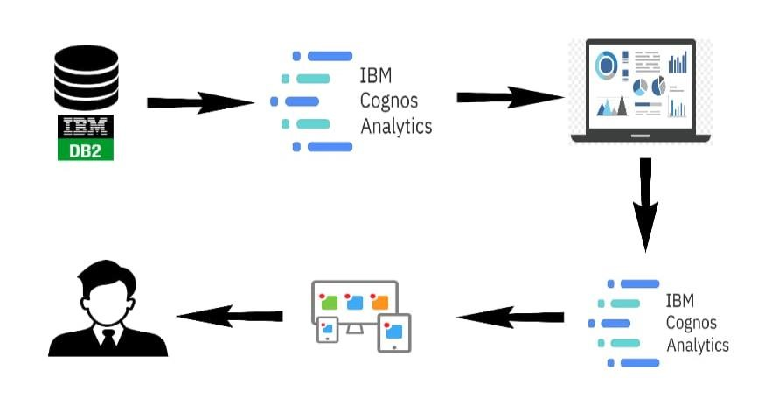

**Framework**

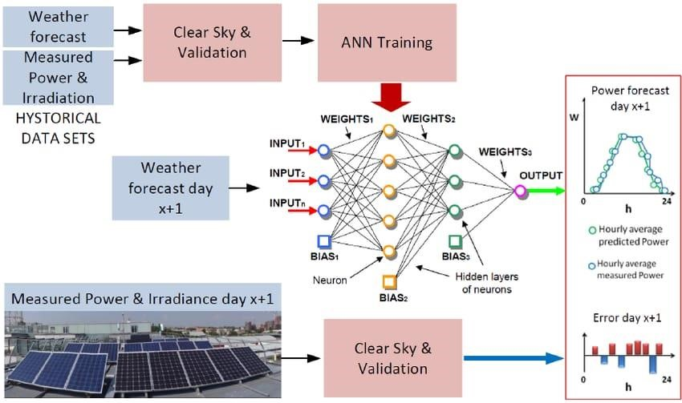

**Abstract:** Renewable energy sources are considered ubiquitous and drive the energy revolution.

Energy producers suffer from inconsistent electricity generation. They often struggled with the unpredictability of the weather. Thus, making it challenging to balance supply and demand. Technologies like artificial intelligence (AI) and machine learning are effective ways to forecast, distribute, and manage renewable photovoltaic (PV) solar supplies. AI will make the energy forecasting system more connected, intelligent, reliable, and sustainable. AI can innovate how energy is used and help find solutions for decarbonizing energy systems. There are potential advantages to total energy forecasting

# Introduction

Nowadays, a significant change in technology within the power system has changed the stable state of the power sector. The power sector is currently taking on a horizon tally integrated system where generation from other alter native sources and the connection of renewable generation to the network are changing magnificently. Thus, the power sector is experiencing a paradigm shift. Electric utilities seek a stable, fair predictable, and commonly operated vertical supply chain. The power system’s objective is to supply electric power to customers reliably and economically. Therefore, electric power consumption and production must be balanced continuously and instantaneously. Power system loads can be described as variability and uncertainty. The load varies throughout the day, whereas the conventional generation can often deviate from schedules. Thus, the contingencies are unexpected, and the load forecast error is also unexpected [1,2].

# Related work

The literature review states many forecasting methods. In quantitative (analytical aspects) [5,6], the forecasted values are developed using certain factors, such as mathematical models and historical data. Quantitative methods are objective in nature. They can be designed using mathematics, and they can be used when past data are available . Unlike the qualitative (social aspects) methods, the fore cast values are developed depending on certain factors such as decision-making, instinct knowledge, experience, and emotion [5,6]. Qualitative methods are subjected to nature and can be used in forecasting intermediate and long-term decisions. Examples of qualitative methods are Jory of execution opinion, where the decision-making is based on a high level and expert management [7] and Delphi method, where the decision making is based on experts and staff [8]. Sales force composite decision making is made by management based on estimates given by an individual sales person . A consumer market method is a survey in which a survey is conducted among the target or prospective customers

# Electrical load forecasting and AI

Electrical energy has to be generated to meet the demand. Therefore, electrical power utilities must estimate the load on their systems in advance. Estimating energy requirements and demand is crucial to effective system planning. Load predictions determine the generation capacity, transmission capacity, and distribution system. The decision-maker should use the available powerplants to serve the predicted load for each hour of the coming week . This estimation is known as load forecasting. It is essential for power system planning. Thus, it starts with a forecast of anticipated future load requirements . Load fore casting is also used to establish procurement policies for construction capital energy forecasts, which are needed to determine future fuel requirements. Thus, a good forecast reflecting the present and future trend sis considered as to all planning.

**System under study**

Jordan has a vast solar energy potential because it is located within the world’s solar belt, with average solar radiation varying between 5 and 7 kW h/m2 as shown in Figure 1, implies a potential of at least 1,000 GW h per year. This work forecasts the total electrical load in one of the significant forefront of Middle Eastern and Jordanian universities. Yarmouk University is a public and compre hensive university. It is located in northern Jordan and was established in 1976. Table 1 shows the plant under study information. Table 2 shows a description of data

# Data collection

Actual yield kW h Expected weather correction yield . (1) Smart meters cause a rich and growing in energy data. Tremendous data are available more than the data in the traditional meters era. These new data resources are analyzed and transformed using machine learning techniques, data mining visualization, and statistical analysis. Transformation into these techniques increases reliability, decreases system cost, and improves environmental sustainability. The characteristics of these big data can be classified into four categories: volume (quantity of existing data), velocity (streaming data),variety(data forms such as numbers, text, and multimedia), and veracity (uncertainty of data quantity). System operators’ data collection strategies can be accomplished in several ways, such as policy mandates implementation for utility-scale and distributed generation, interconnection or market requirements set by the government, utility power purchase agreements

**Methodology** The base of forecasting methodology is the components used in the model , application sof the forecast , and challenges experienced . The appeal of fossil fuelsis that they can deliver power at all times of the dayand can be turne donand off. Solar energy faces an intermittency issuethatis not continuously available for power conversion. It fluctuate son cloudy days .Thus, the sun hours contributed significantly to prediction accuracy

**Random Forest algorithm**:

It consists of numerous decision trees that use two fundamental concepts :

1. random sampling of training data points when creating the trees and
2. random subsets of features examined when splitting the nodes. A decision tree is one of the predictive models where the target variable can take a discrete or continuous set of values. The leaves indicate class labels, whereas the branches represent feature combinations that lead to those labels.

**Bagging algorithm**:

It is a bootstrap aggregate a learning approach that combines numerous base models to produce a single best predictive model [17]. The REF Tree model is used as the base model in this article since it produces better results on the dataset. Each model is trained independently, with the results combined using an average process. The primary focus of bagging is to achieve less variance than any model has individually.

**Test Set Linear Regression algorithm**:

It is a supervised machine learning approach that uses a polynomial slope-intercept form to connect the independent and dependent variables, with the projected output being acontinuousnumber[18]. In particular, the algorithm learns the best fit of the line between the inputs (inde pendent variables) and the outputs (dependent vari ables) by reducing the error estimated from the pre dicted and actual targets

**Support Vector Machine algorithm:**

It is a super vised machine learning technique that can be used to solve issues in classification and regression [19]. Each data item is represented in the SVM method as a point in n-dimensional space (where n is the number of features or inputs), with the value of each feature being the value of a certain coordinate. Following a that, classification is carried out by locating the hyperplane that separates the two target classes.

**Experiment and results**

We conducted several experiments to validate predicting the future consumption of solar power generated from solar panels. ML techniques receive the input dataset and extract the inherited knowledge with in a huge amount of records by using a mathematical pattern. As discussed, each ML model maintains its own unique strategy to reduce the error prediction between the actual and the model’s output, resulting in varied outputs on distinct datasets. Table 6 provides the results of ML models using the five evaluation metrics. The Random Forest model obtains a superior outcome compared to other techniques with a CCvalueof0.9751, which is approximately identical to the Bagging _REFT re model’s result of 0.9729. These results indicate that the tree-based approaches outperform the other models.